Smash Bros. 64 Animation Guide

Hi there! If you're reading this you're probably wanting to make animations for Smash 64 mods.
Well let's get started then! This guide will only cover the animation and exporting end result of
said animation with the Autodesk Program Maya. If you don't already have Maya 2016-2019, then fear not, you can easily create a student account to get a free whopping 3 year trial to use
any autodesk product on their website. and it's completely safe and virus-free, I can vouch for it.

Hi there! If you're reading this you're probably wanting to make animations for Smash 64 mods.
Well let's get started then! This guide will only cover the animation and exporting end result of
said animation with the Autodesk Program Maya. If you don't already have Maya 2016-2019, then
fear not, you can easily create a student account to get a free whopping 3 year trial to use
any autodesk product on their website. and it's completely safe and virus-free, I can vouch for it haha.

What you'll Need:
1. Maya 2016, Maya 2017, Maya 2018, or Maya 2019 (I haven't tested the later versions beyond this
so I don't know if those will also work)
2. a Smash 64 Character's rigged unaltered model in it's default A-pose which is usually in FBX Format
(textures aren't necessary for this)
3. FBX rips of ideally most of the animations from the vanilla game for the character in question.
This will be needed to set up a comparison for their "Idle" pose to transition to and from, as well
as their "Airfall" pose.
4. The Current version of the GE Editor

ANIMATING SET UP:

Now for the first step it's pretty simple, you have to boot up Maya and start by going to File, then importing the Raw, ripped, unedited rig of the character in question that you're trying to animate from Smash 64 (let's say it's Mario or a custom clone character based on Mario's rig just as an example). Usually, said character model file will be in FBX format since FBX is typically what models with skeletons come with. Once the character is loaded into the scene, the model will usually automatically start in a T-pose or an A-Pose (in the case of Smash 64 it's usually an A-pose for characters, except Link). This is their default pose position before keyframes are loaded onto their bones to animate them.

Before we move on, look near the bottom right and you'll see an icon of a stick-figure running from a cog. click on it and you'll be at the Preferences. From there, click on "Settings" on the list that pops up and under the "Working units" section you'll see a tab for "Time". By default it's at 24 FPS. You'll want to change this to 60 FPS since that's the speed of Frames that Smash 64's engine reads at. After that is set you can close the preferences window.

What you'll want to do next is go to the gray tab near the top left that should say "Modeling". Hit that tab and it should open up a list. from there, switch it from "Modeling" to "Rigging". Once you do that, you'll notice the selection of options on the top will slightly change, and one of the new options will be "Skeleton". Hit that, and on the bottom of the subsequent list will be a "HumanIK" option. Select it. This will be imperative to making the animation process for most of the 64 characters far more streamlined for beginners.

On the Right side, you'll then see a tab that gives you a list of more HumanIK control options. Hit the one that says "Create Character Definition". It'll then change to a reference image of a humanoid stick figure person which will serve as a visual guide for you to map the skeleton's bones to the HumanIK controller rig. This next part is rather self-explanatory: go to Windows, then hit "Outliner" and an additional tab will pop up containing the outliner (duh). One of the entries on the list will say "Top Joint". this is the root bone of the skeleton we are going to be animating for the character. expand the list from the "Top Joint" bone (this bone is used to determine actual movement of the character) and below it, you will see a hierarchy of bones with odd naming (for Mario the first bones are called "FBXASC048", "FBXASC049", etc). You're going to have to play around with each bone and be hitting Ctrl+Z a lot in order to find out which bone controls which part of the body, and avoid the unsafe bones (listed in GE Editor for each character when loaded). So for example, the right Forearm on the HumanIK visual is what I'd map Mario's Bone "FBXASC0491" to since they match (and of course that bone also falls under the "safe" category to animate with). And the same logic should apply to the other parts of the body. Continue to map visual reference until the stick figure's body parts are all mostly green (some parts occasionally turning yellow is fine usually). If done correctly, the red X button next to the visual reference HIK mapping should turn into a Green checkmark button, which means we have officially set up control rigs for our character to animate with! Then just look right above that and you'll see a gray tab that says "None" right next to the word "Source". Hit the "None" tab and change it to "Control Rig". From there you'll have to mess around a bit with the HIK controls to get a better understanding of how they work, but it shouldn't be too hard to understand after a couple minutes of tinkering.

Now that the basic human IK controls for Mario have been set up, now we have to make sure his frame 1 position is set via keyframing. For users who wish to animate a grounded tilt attack,
or a jab or Smash attack, you'll need the starting frame 1 keyframe pose and the last frame be his "Idle/waiting" position. For an aerial attack animation, You'll need to have the first
keyframed pose on Frame 1 and whatever the last Frame is be the "Falling/Air" pose. this is so that the custom animations/attack moves for Mario can transition to and from his other
existing animations seamlessly. this of course also applies to other characters that people would be animating for in Smash 64. To match Mario's Frame 1 keyframing to the exact pose
position of his idle from the game, we'll need to open one more separate Maya tab and use that to import one of the FBX rips of Mario's animations. In this case, it'd be his Wait1 animation or Idle. once it's imported into a Maya scene, go to the timeline near the bottom and delete all the many keyframes except for the frame on frame 1. Then save it as a new Maya.Binary scene file somewhere on your desktop somewhere. Then you can close that spare Maya tab as you'll no longer need it.

Go back to your original still-opened Maya scene that has the Mario rig with controls already set up, and go to "File", then "Import" once again. this time, import the Maya Binary scene
you just created into this one. You'll then see a second Mario loaded on top of the existing A-posed mario. You'll then use your HIK controls to make the A-posed Mario's body pose/position
match the position on frame 1 of the second freshly imported Mario. Once the original HIK-controlled Mario overlaps (or is generally close to overlapping, doesn't need to be absolutely
precise, just ballpark it till it looks reasonably close), then hit "S" on the keyboard to keyframe on frame 1 of the HIK Mario Timeline. you'll then finally see a red line on frame 1 for the
HIK-controlled Mario you worked so hard to set up, indicating that you now have a Mario with animation controls set up, with it's initial pose correctly replicated and ready for animating
custom moves and attacks with!

To wrap things up, Make sure you go back to the outliner and delete all the objects of the second duplicate posed mario that you no longer need. Happy animating!!

FINISHING UP/EXPORTING:

Once you've created a solid animation for Mario/a Smash 64 character that you're happy with, there's still one last thing you gotta do: export it as an FBX file. Since we animated this with HIK, we'll need to do an extra step as well for this last part. First, you'll need to go back to the outliner and Ctrl+Left Click all the bones that can be animated/keyframed with. Once that's done, go to the gray tab near the top that currently says "Rigging" (It formerly should've said "Modeling" if you remember back at the beginning of this guide). Then change it to "Animation" Instead. Once again, you'll notice a few options on the top will change. This time, go to "Key" and click on the small square box to the right of "Bake" or "Bake Simulation" (depending on your Maya version). a new tab will pop up, and so you'll need to go to "Time Range" and switch the setting next to it from "Time Slider" to "Start/End". Once you've checked that, obviously make sure the start frame is set to "1" and the end frame set to however long the animation you just made was (let's say I made an animation that was 70 frames long, then I'd make the end frame box say "70"). Then scroll to the bottom of this same tab till you find "Smart Bake" and make sure that's unchecked. And also make sure the "Keep unbaked Keys" box is checked. Once all the preparations are complete, double check to make sure the safe bones you clicked and highlighted in the outliner are still highlighted, then you can finally hit "Bake" in the Bake simulator options tab. This will keyframe every frame on all the safe bones of your custom animation.

With the animation finalized, baked/keyframed, and still selected, all you must do now is go to "File" and then "Export Selected". make sure you export the animation file as an FBX,
and on the right side of the export tab you should see "FBX file format". the type should be Binary, and the version tab should be changed to "FBX 2014/2015". When you're all ready to
go, hit export and voila! you just created your own custom Smash 64 animation that's ready to be imported into the game!

FINAL TIPS FOR ANIMATING IN SMASH 64:

Be sure to exaggerate your poses! Make sure your character
really leans in and puts all their weight into every key pose to really sell the power of the attack.
And don't forget to scale/stretch the limbs and body parts towards the end of the process to
further exaggerate the power behind the attacks!

IMPORTING:

- Start the GE Editor and click toolsanimation editor

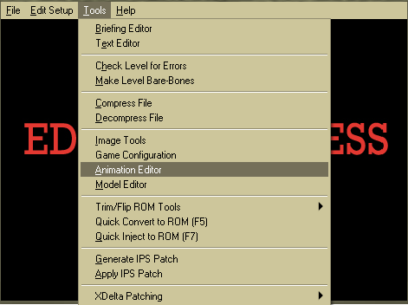

- Select your character of choice

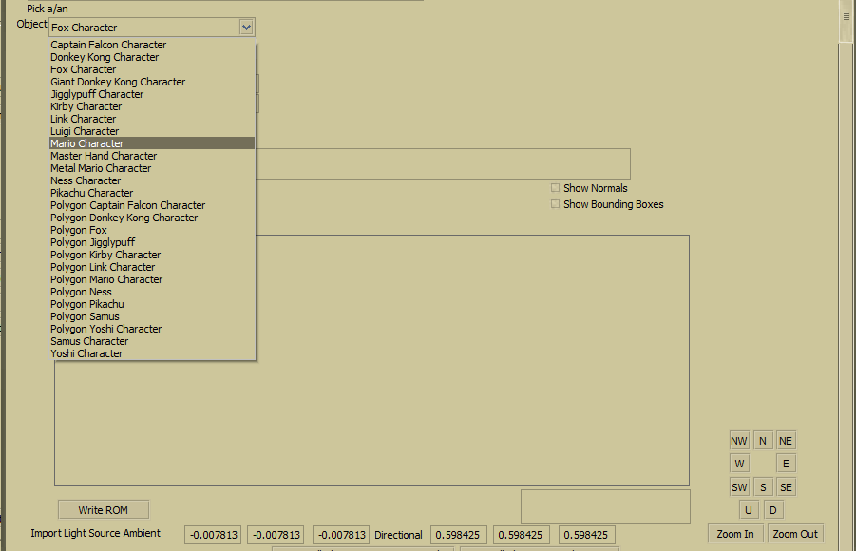

- Look up your animation of choice (may not be labeled):

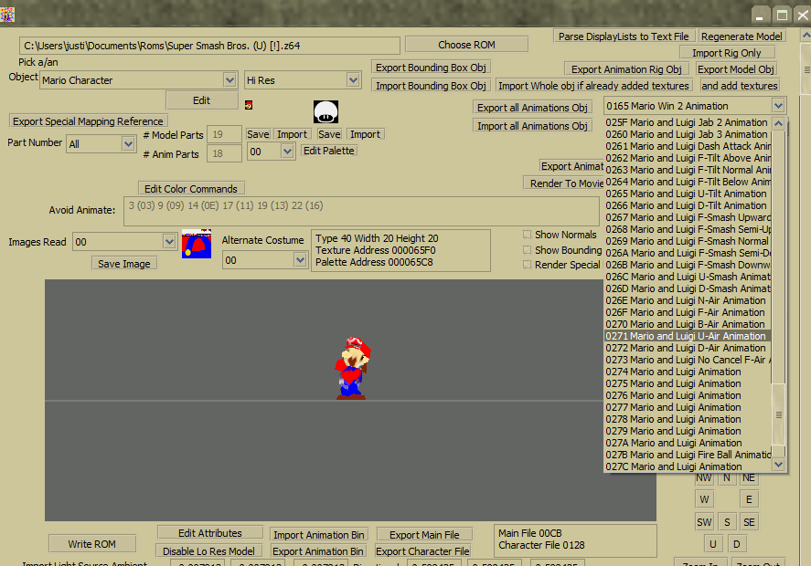

- Import your FBX and “Write Rom”

Then all that’s left is to test your newly imported animation by opening it up in an emulator. Some animations like walking will require you click the “looping” checkbox in order for them to work correctly.

